**1, Use Case for Technical Staff:**

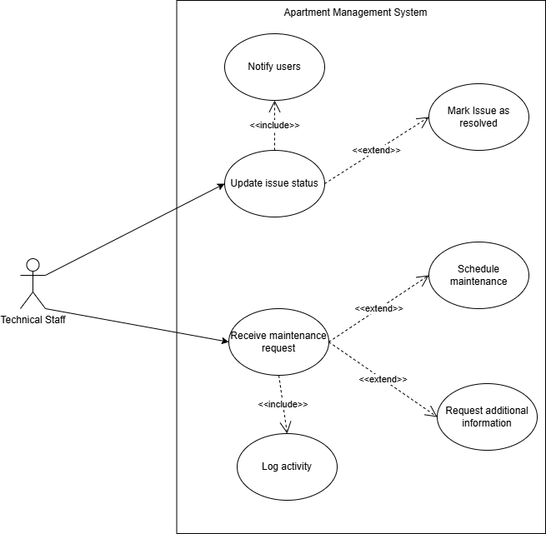

UC Receive maintenance request

#### 

| UC ID and Name: |  | | |
| --- | --- | --- | --- |
| Created By: | HieuLH | Date Created: | 26/05/2025 |
| Primary Actor: | Technical Staff | Secondary Actors: | None |
| Trigger: | A new maintenance request is submitted by a resident or auto-generated by the system. | | |
| Description: | As a technical staff member, I want to receive and view new maintenance requests so I can process them effectively and in a timely manner. | | |
| Preconditions: | * The actor must be logged into the system. * At least one maintenance request exists in the system queue. | | |
| Postconditions: | * The request is marked as “Received” or “In Progress”. * The activity is logged in the system activity log. | | |
| Normal Flow | **Receive Maintenance Request**   1. Technical staff logs into the system. 2. The system displays a list of incoming maintenance requests. 3. Staff selects a request to view its details. 4. Staff marks the request as “Received” or “In Progress”. 5. The system logs this action in the activity history. | | |
| Alternative Flows: |  | | |
| Exceptions: | **Invalid or Missing Request Data:**  If the request is missing required information, the system highlights the missing fields.  Staff is prompted to reject the request or request additional information from the resident. | | |
| Priority: | Must Have | | |
| Frequency of Use: |  | | |
| Business Rules: |  | | |

#### 

UC Update issue status

| UC ID and Name: |  | | |
| --- | --- | --- | --- |
| Created By: | HieuLH | Date Created: | 26/05/2025 |
| Primary Actor: | Technical Staff |  |  |
| Trigger: | Staff selects a maintenance request and chooses to update its current status. | | |
| Description: | As a technical staff member, I want to update the status of a maintenance issue so that other stakeholders are aware of the progress and resolution of the task. | | |
| Preconditions: | * Technical staff is logged into the system. * A valid issue/maintenance request exists in the system. | | |
| Postconditions: | * The issue status is updated successfully. * The resident is notified of the status change. | | |
| Normal Flow | **Update Issue Status**   1. Technical staff logs into the system. 2. Staff accesses the list of assigned or open maintenance issues. 3. Staff selects a specific issue. 4. Staff updates the issue status (e.g., "In Progress", "Resolved", "Waiting for Parts"). 5. System saves the update. 6. System notifies the resident about the status update. | | |
| Alternative Flows: |  | | |
| Exceptions: | ***Unauthorized or Invalid Update***   * If the staff tries to update a request not assigned to them or one that is already closed, an error message is displayed. * If required status transition rules are violated (e.g., skipping statuses), the update is rejected. | | |
| Priority: | Must Have | | |
| Frequency of Use: |  | | |
| Business Rules: |  | | |

**2, Use Case for Security Staff:**

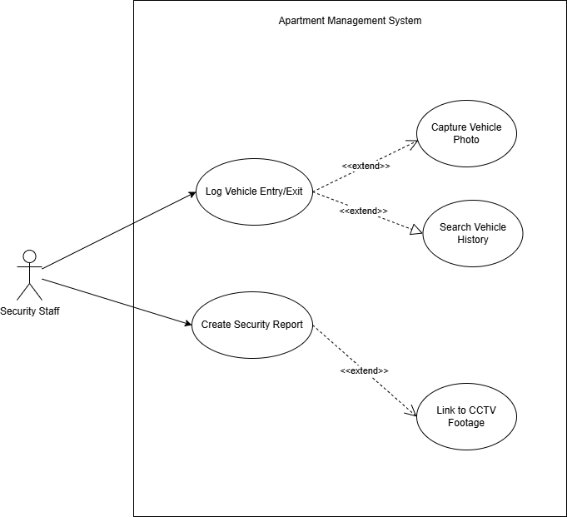

UC log vehicle Entry/Exit

#### 

| UC ID and Name: |  | | |
| --- | --- | --- | --- |
| Created By: | HieuLH | Date Created: | 26/05/2025 |
| Primary Actor: | Security Staff | Secondary Actors: | None |
| Trigger: | | A vehicle arrives at or departs from the apartment premises and needs to be recorded in the system. | | --- | | | |
| Description: | As a security staff member, I want to log each vehicle's entry or exit so that the apartment system can track all vehicle movements for security and auditing purposes. | | |
| Preconditions: | * The security staff is logged into the system. * The system is operational and connected to the vehicle log database. | | |
| Postconditions: | * A new vehicle entry/exit record is saved in the system. * Vehicle log is available for future searches. | | |
| Normal Flow | **Record Vehicle Movement**   1. Security staff opens the Vehicle Entry/Exit module. 2. Staff selects “Entry” or “Exit”. 3. Staff enters or scans the vehicle license plate. 4. Staff inputs timestamp or confirms automatic time detection. 5. Staff confirms and submits the record. 6. System saves the record and shows success notification. | | |
| Alternative Flows: |  | | |
| Exceptions: | **Invalid License Plate Input**   * System shows an error and prompts for re-entry.   **Camera Unavailable**   * Photo is skipped with a warning message, but record is still logged.. | | |
| Priority: | Must Have | | |
| Frequency of Use: |  | | |
| Business Rules: |  | | |

UC Create Security Report

#### 

| UC ID and Name: |  | | |
| --- | --- | --- | --- |
| Created By: | HieuLH | Date Created: | 26/05/2025 |
| Primary Actor: | Security Staff | Secondary Actors: | None |
| Trigger: | | An incident occurs that requires formal reporting. | | --- | | | |
| Description: | As a security staff member, I want to create a security report in the system to document incidents or abnormal events for further review and evidence keeping. | | |
| Preconditions: | * Security staff is authenticated. | | |
| Postconditions: | * A detailed report is created and saved in the system. * Report is accessible to administrators and relevant stakeholders. | | |
| Normal Flow | **Create Incident Report**   1. Security staff accesses the report creation form. 2. Staff inputs details:     * Time & date of incident    * Description    * Persons involved    * Actions taken 3. Staff optionally attaches files (e.g., photo evidence). 4. Staff submits the report. 5. System saves the report and logs submission time. | | |
| Alternative Flows: |  | | |
| Exceptions: | **Missing Required Fields**   * System prevents submission and highlights missing inputs.   **Footage Unavailable**   * Staff is notified, but can still proceed without linking CCTV. | | |
| Priority: | Must Have | | |
| Frequency of Use: |  | | |
| Business Rules: |  | | |